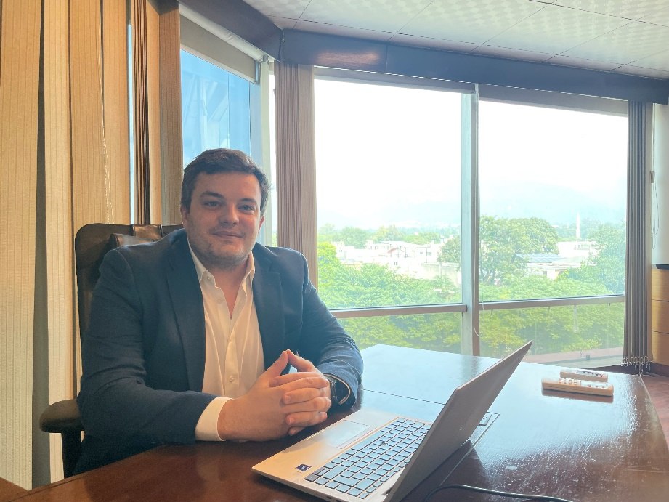

Kieran Griffin

Principal Manager, Conflict, Stabilization, and Peacebuilding

Kieran brings over a decade of experience at DAI, where he leads high-performing proposal and project teams in dynamic environments. Joining DAI Global as an Administrator in 2013, Kieran now serves as a Principal Manager, spearheading initiatives in conflict, stabilization, and peacebuilding. With extensive global experience across the Middle East, Africa, and Asia, he is responsible for developing new business opportunities and managing a diverse portfolio of projects.

Kieran is dedicated to crafting compelling proposals, building strong client relationships, and tackling complex implementation challenges. His commitment to excellence in international development fuels his passion for empowering teams and delivering impactful results on a global scale.

In his spare time, Kieran enjoys golfing, traveling, and spending quality moments with his pets.

* BSc, International Studies (Politics and Economics), Open University, 2015-2020
* NVQ Level 2, Leadership and Team Management, 2012
* NVQ Level 2 and 3, Business Administration, 2011